# **CTF Challenge: Website Security Assessment - Using GoDaddy SSL Checker**



# **1. Introduction**



GoDaddy SSL Checker is a tool designed to inspect SSL/TLS certificates installed on websites hosted with GoDaddy. This challenge will familiarize you with using GoDaddy SSL Checker to evaluate the SSL/TLS configuration of a specific domain.

# **2. Tools and Requirements**

Access to the internet and open GoDaddy SSL checker

# **3. Scenario**



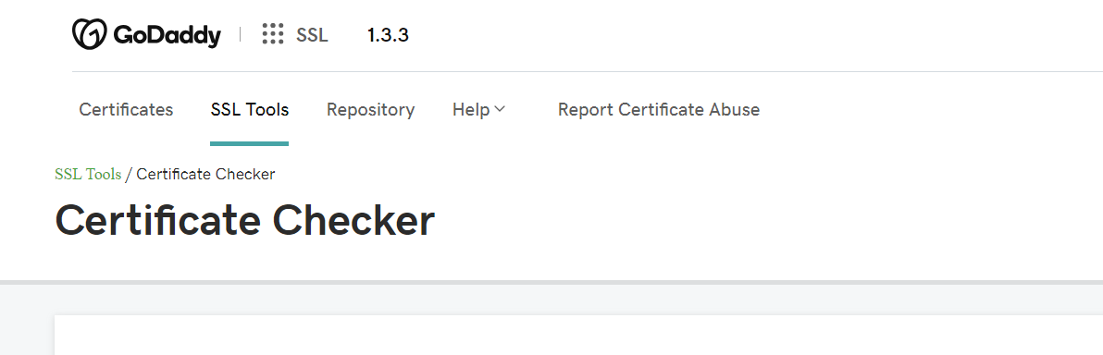

You are an IT administrator responsible for maintaining the security of your organization's websites hosted on GoDaddy. Your task is to use GoDaddy SSL Checker to assess the SSL/TLS certificates of one of the critical websites and identify any security vulnerabilities.

# **4.Process to follow while performing CTF**

1. Go to **GoDaddy** **SSL Checker:** [**https://ssltools.godaddy.com/views/certChecker**](https://ssltools.godaddy.com/views/certChecker)

2. Search: Enter the domain[**https://www.root-me.org/**](https://www.root-me.org/)in the search bar and start the search.

3. Solve the CTF.

# **5. Let’s Begin the Challenge**

**Question**

**Flag 1: What is the IP Address of the website?**

**Answer:** 212.129.28.16

**Flag 2: IS SCSV Fallback Enabled or Disabled.**

*Answer: Enabled*

**Flag 3: What is the Status of OCSP?**

*Answer: Good*

**Hint:**



